# MEMORANDUM

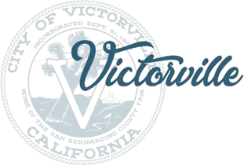DATE: June 21, 2023

TO: Distribution List

FROM: Charlene Johnson

Planning Department

SUBJECT: ACTIONS TAKEN AT THE JUNE 21, 2023 REGULAR MEETING of the zoning administrator

The following is a brief resume of the Zoning Administrator actions taken at the above meeting. Present at the meeting were: Acting Zoning Administrator Alex Jauregui, Planning Technician Charlene Johnson and approximately 2 attendees. Please contact the Development Department if you have any questions or need additional information.

Meeting Opened: 10:00 a.m.

Call to Order

**PUBLIC HEARINGS**

1. ADMN23-00034 – Youhanna Gad

ENVIRONMENTAL – Environmental Exemption

PROJECT – A Minor Conditional Use Permit with an Environmental Exemption to allow for an outpatient medical office and surgery center.

LOCATION – 12241 Industrial Boulevard

Acting Zoning Administrator Alex Jauregui opened the Public Hearing.

Speakers:

None

Acting Zoning Administrator Alex Jauregui closed the Public Hearing.

**Approved as Conditioned.**

1. ADMN23-00042 – Moses House Ministries

ENVIRONMENTAL – Environmental Exemption

PROJECT – A Minor Interim Use Permit with an Environmental Exemption to allow for a Family Services Organization to occupy an existing building zoned C-2 (General Commercial).

LOCATION – 14281 Seventh Street

Acting Zoning Administrator Alex Jauregui opened the Public Hearing.

Speakers:

Matthew Coughlin (Applicant)

James Phillips (Property Owner)

Acting Zoning Administrator Alex Jauregui closed the Public Hearing.

**Approved, with modifications to Conditions of Approval 8-10.**

**PUBLIC COMMENT ON ITEMS OF INTEREST TO THE PUBLIC**

Speakers:

None

**ADJOURNMENT**

Meeting was adjourned at **10:23 a.m.**